Project Design Phase-II
Data Flow Diagram & User Stories

Date | 20 February 2026
Team ID | LTVIP2026TMIDS77212
Project Name | FreelanceFinder: Discovering Opportunities, Unlocking Potential
Maximum Marks | 4 Marks

Data Flow Diagrams:
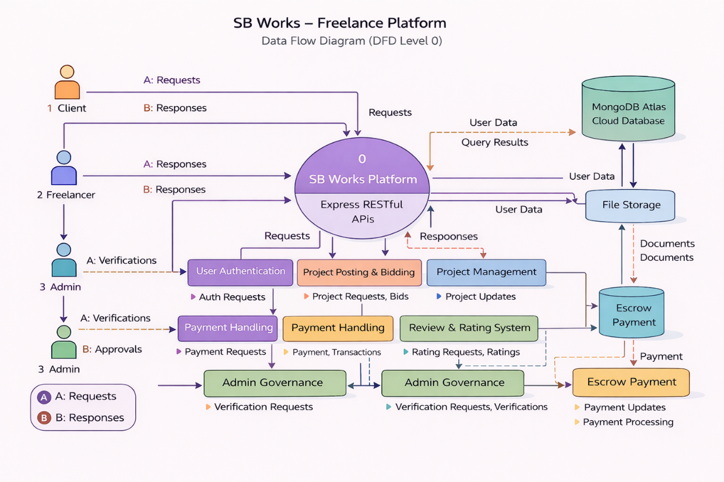

User Stories
User Type | Functional Requirement (Epic) | User Story Number | User Story / Task | Acceptance criteria | Priority | Release
Client (Web User) | Registration | USN-1 | As a user, I can register using email and password | Account created & dashboard accessible | High | Sprint-1
Client / Freelancer | Authentication | USN-2 | As a user, I can log in securely | Successful login redirects to dashboard | High | Sprint-1
Client | Project Posting | USN-3 | As a client, I can post a new project with details | Project appears in project listing dashboard | High | Sprint-1
Freelancer | Project Browsing | USN-4 | As a freelancer, I can view available projects | Project list loads from database | High | Sprint-2
Freelancer | Bidding System | USN-5 | As a freelancer, I can submit a proposal for a project | Proposal saved and visible to client | High | Sprint-2
Client | Freelancer Selection | USN-6 | As a client, I can select a freelancer from proposals | Selected freelancer status updated to “Assigned” | High | Sprint-3
Freelancer | Project Management | USN-7 | As a freelancer, I can update project status | Status updates to Ongoing / Completed | High | Sprint-3
Client | Review & Rating | USN-8 | As a client, I can rate a freelancer after completion | Rating saved and displayed on freelancer profile | Medium | Sprint-4
Admin | User Monitoring | USN-9 | As an admin, I can monitor platform activity | Admin dashboard shows user and project data | Medium | Sprint-5

